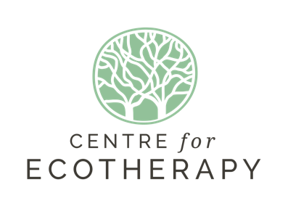
2024 Monday Drop-In
Client Information Form

Please note that information in this questionnaire will be kept confidential.

Title Full Name:

Date of first session (if known)

Gender:

Date of birth:

Address & Postcode

Contact Numbers:

Email:

Please provide name, relationship,
and contact details we can use
in an emergency:

Name, contact number and email of

support worker or mental health
professional if you have one.

Do you have any health conditions that could affect your ability to participate this session?
(e.g. heart problems, sensitivity to sunlight, asthma, high or low blood pressure)

Do you have any allergies or are you taking any medication that the session leaders need to be aware of?

Are you happy for us to keep you updated on activities at The Centre for Ecotherapy? Yes  No 

Preferred method: Email  Phone call  Text  Any 

Are you happy to be contacted in the future to help us evaluate our activities? Yes  No 

Equalities Monitoring
What do you consider your ethnicity?

What do you consider your employment status?

Where did you hear of the Centre for Ecotherapy?
Eg. Brighton and Hove Food Partnership, Grow, CPN, website, other?

Reason for attending this activity? What would you like to achieve?
Eg. Improved well-being, reduce anxiety, increase confidence, sense of purpose, improve social life, new knowledge/skills, other?

On this line, place a mark to indicate how you feel in your personal well-being at this stage in your life.
☹ ----------I----------☺
Disclaimer: I understand that if I have a health condition which could affect my ability to undertake this activity, I should seek medical advice before exercising and will tell a staff member if my condition changes. I understand this information will be shared with other leaders and I participate at my own risk.

Signed Date

Thank you for completing this form.

