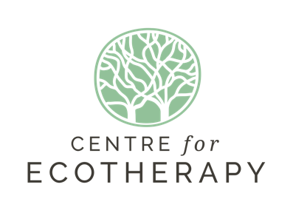

TEAM BUILDING DAY PRICES 2022

- Site rental only.

You rent the site and do with it/be in it as you will, bring your own
lunch/drinks etc.

£45 for half a day
£90 for a full day

2. Site rental and refreshments full day (unfacilitated)

You rent the site and we provide drinks and lunch but you
manage/ facilitate the day as you choose

£225

3. Facilitated Team (Half day) - Drinks included but no lunch

£250

4. Facilitated Team (Whole day) – Drinks and lunch included

We provide a fully facilitated team day:
Package A or B to be decided, according to your team's needs
Drinks/lunch

£500

Packages:
We want you to choose the best ‘day’ for your group. You may wish for your team to work the whole day at tasks that benefit the Centre OR to benefit themselves from some ecotherapy exercises that encourage nature connection, personal reflectiveness and a cohesiveness amongst peers that comes from sharing the experiences of these exercises. Or you may like a mixture of both.
The Centre offers you the choice to build the package you feel most appropriate for your team:

Package A: Two practical tasks that benefit the Centre for Ecotherapy or the surrounding community/environment.
Tasks will be chosen by the Centre’s staff and be practical and horticultural in nature. Tasks could include: wheelbarrowing woodchip to cover social areas and pathways, digging, pruning and cutting back vegetation, care of plants and vegetables, wood gathering, sawing and preparing wood to store for future fire use, maintenance of project’s tools/resources etc. All tasks will be supervised and teams will receive instruction on how to achieve the outcomes successfully.

Package B: One practical task and one Ecotherapy exercise
The morning or the afternoon can be spent with the team completing a task beneficial to the Centre while the other ‘session’ will be spent taking part in an Ecotherapy exercise that will develop the individual team members’ experience of nature as a healing medium. Self reflection and sharing of experiences will be a part of this exercise and therefore brings a sense of understanding and bonding to the team as a whole.
On booking your Team Building Day with us, please indicate which package you would prefer. Or if you have another idea you would like to incorporate, please feel free to discuss that with us. Also, if you are a community organisation for whom funding is a challenge and you consider yourselves unable to afford the above full price but know your team would benefit from the day, please get in touch.
For more information, please email to info@centreforecotherapy.org.uk or call
07517 09915

We look forward to welcoming you to the Centre for Ecotherapy, Stanmer Organics, Stanmer Park.

