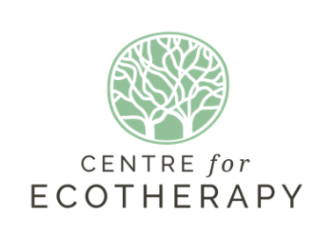
Please use this form if you would like to hold an event or workshop at the Centre for Ecotherapy. Completed forms should be emailed to: bookings@centreforecotherapy.org.uk.
Cost for rent of site:
Half day session 9am-1pm or 1.30-5.30pm or evening session 6-10pm- £45
Full day session 9am-6pm - £90
Morning to evening 9am-10pm - £135
(If your timing for a 4/4.5 hour session cuts through the middle of the day meaning that another group could not use it for another half day session ie. 11-3.30, you will need to book both sessions)
Cancellation policy: If the Centre for Ecotherapy cancels the hire you will receive a full refund;
If you cancel your attendance up to 14 days before the date you will receive a 75% refund;
If you cancel up to 7 days before the date you will receive a 50% refund.
There is no refund if you cancel within 7 days of the date or do not attend on the day.
NB: Organisations using fire MUST bring own firewood.
No foraging for firewood allowed on Centre for Ecotherapy or Stanmer Organics land.

Group/ individual name:
Contact email:
Phone Number:
Insurance for session held? | Yes/ No
Date (s) of event/s:
Expected/estimated number
Timings e.g. full day, half day

Purpose of event:
If for an organisation is it: | For profit / Not for profit
Will you be charging for attendance at the event? | Yes / No
If yes, how much will you charge?
Any other comments or special requirements:

Please note that The Centre for Ecotherapy will only confirm your site booking once a payment is made. Please make a payment 30 days prior to your event/workshop or immediately if your booking takes place in less than 30 days.

To make a payment:
Please make BACS transfer to Coop Ban Sort Code 08-92-99 Acct no. 65727849
Or cheques payable to The Centre for Ecotherapy and send: C/o Community Base, 113 Queens Rd, Brighton, BN1 3XG

